**Observability in OpenShift**

**Illuminating Cloud-Native Insights**

|  |  |  |
| --- | --- | --- |
| Edition | Date | Author |
| 1.0 | Sept 13, 2023 | Brijesh Doshi, Yogendra Srivastava |
|  |  |  |

Table of Contents

1. Introduction 3

2. Empowering Openshift with Observability 3

2.1 Trends Pioneering Observabilty 4

3. Eleavating observability with Dynatrace Operator on Redhat Openshift 6

4. Full stack observabilty for redhat openshift 7

5. Types of Operators in observability with instana 7

6. Why choose Instana with OpenShift. 8

7. Reference 9

1. **Introduction:**

In the dynamic landscape of cloud-native technologies, the imperative of observability has grown exponentially. Enter OpenShift, the robust Kubernetes-based container platform, offering a comprehensive ecosystem to achieve observability. Developers and operations teams are bestowed with unparalleled insights into application performance and infrastructure. Join me in this blog as we delve into the realm of observability within OpenShift.

**Deciphering Observability vs. Monitoring:**

As the embrace of cloud-native infrastructure accelerates, the demarcation between observability and monitoring emerges as pivotal. Cloud-native observability tools are meticulously crafted to gather and dissect data from microservices, containers, and other cloud-native entities. This realm is upheld by four distinct pillars:

* **Metrics**
* **Logs**
* **Traces**
* **Events**

**The Boons of Observability in OpenShift:**

* **Rapid Troubleshooting:** Real-time insights expedite issue identification and resolution, minimizing downtime and reinforcing system reliability.
* **Optimized Resource Management:** Observability empowers administrators to reallocate resources based on real-time utilization data, culminating in cost efficiency.
* **Elevated User Experience:** Swift identification and resolution of performance bottlenecks pave the way for seamless and enchanting user interactions.

**2. Empowering OpenShift with Observability:**

Our recent OpenShift 4.13 release heralds ground-breaking observability enhancements:

* **Unified Metrics:** An enhanced OpenShift Monitoring UI experience boasts unified and integrated metrics, eliminating the need for separate 3rd party UI management. Integrated alerting via Alert Manager simplifies end-to-end monitoring, complemented by Red Hat's robust support.
* **Augmented Audit Logging:** Metrics within the Prometheus adapter now embrace audit logging, enabling observation of component interactions with the metrics API. This empowers customers to troubleshoot performance issues via API audit capability.
* **Query Logging Unveiled:** Enable query logging across all Prometheus Instances, leveraging ThanosQuerier to monitor frequently executed queries and their operational implications.
* **Client Certificate Authentication:** Prometheus can now leverage Client Authentication for scraping metrics, mitigating performance impact on authentication APIs and aligning with Global OpenShift Security Configurations.

**2.1 Trends Pioneering Observability:**

* **AI and ML Integration:** Artificial intelligence and machine learning spearhead automated anomaly detection, predictive insights, and root cause analysis, expediting issue resolution in complex systems.
* **Hybrid and Multicloud Embrace:** The surge of hybrid and multicloud strategies mandates observability tools that offer holistic infrastructure insights, transcending deployment locations.
* **Navigating Edge Devices:** As edge devices and IoT flourish, real-time insights and rapid responses are paramount, necessitating lightweight data collection agents, edge-friendly formats, and decentralized analysis fortified by robust security.
* **Observability in DevOps:** As the cornerstone of cloud-native application reliability, observability seamlessly integrates into DevOps practices, augmenting the toolchain for continuous enhancement.
* **Open Source Ascendance:** Open source observability tools like Grafana, Jaeger, Kafka, Open Telemetry, and Prometheus ascend, fueling the evolution of the observability landscape.

**3. Elevating Observability with Dynatrace Operator on Red Hat OpenShift**

In 2018, Dynatrace introduced a game-changing innovation - the Dynatrace Operator, built upon the Operator Framework open-source project. This Operator has revolutionized Kubernetes and Red Hat OpenShift clusters, streamlining deployment, configuration, maintenance, and upgrades of the Dynatrace full stack observability suite.

Excitingly, Dynatrace and IBM have united to usher in a new era. This collaboration brings the power of the Dynatrace Operator and the extensive Dynatrace platform to Red Hat OpenShift.

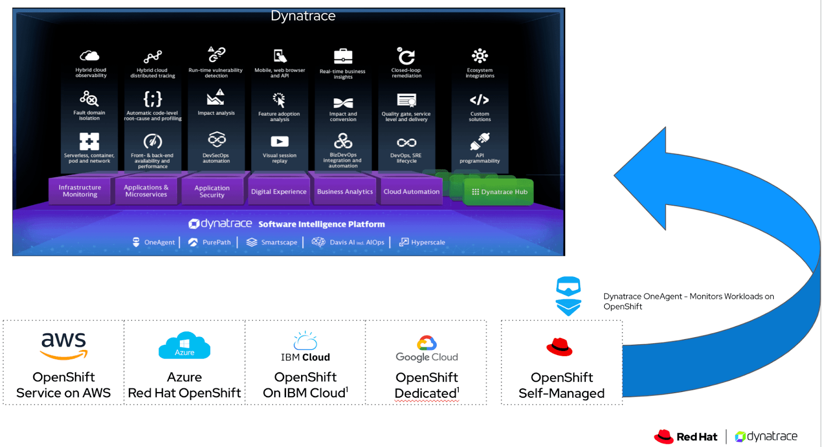

**4. Full-Stack Observability for Red Hat OpenShift**

Bringing platform engineering and application teams together, Dynatrace fosters enhanced software quality, operational efficiency, and innovation. The distinctiveness of Dynatrace's Red Hat OpenShift monitoring stems from:

* **Infrastructure Health Monitoring and Optimization:** A quick scan reveals infrastructure health, resource usage insights, efficient resource allocation, and software version tracking within the Kubernetes ecosystem.
* **Complete Stack Observability:** It captures metrics, traces, logs, and telemetry data in context. Integration with cloud-native technologies like Istio and Prometheus enriches its monitoring capabilities.
* **Smartscape Topology Mapping:** Through Smartscape technology, Dynatrace semantically maps metrics, traces, logs, and real user data to specific Kubernetes entities—containers, pods, nodes, and services.
* **Intelligent Root Cause Analysis:** Leverage Davis® AI to autonomously detect and dissect performance issues throughout the tech stack. Davis identifies problematic components, configurations, and offers insights into root causes, expediting troubleshooting.
* **Scalability and Cloud-Native Support:** Designed for dynamic Kubernetes environments, Dynatrace seamlessly scales, supports GitOps practices, and effortlessly manages extensive deployments with thousands of nodes and containers, catering to enterprise-grade Red Hat OpenShift monitoring.

**5. Types of Operators in OpenShift observability**

|  |  |  |
| --- | --- | --- |
| **Type of Operator** | **Functionality and Purpose** | **Platform** |
| Prometheus Operator | Allows to set up custom Prometheus instances to collect metrics from your applications and infrastructure | OpenShift, Kubernetes |
| Grafana Operator | Used to create interactive and customizable visualizations based on the metrics collected by Prometheus or other data sources | OpenShift, Kubernetes |
| Jaeger Operator | Provides end-to-end tracing of requests across microservices, aiding in diagnosing latency and performance issues | OpenShift, Kubernetes |
| Elasticsearch Operator | Facilitates the deployment and management of Elasticsearch clusters, which can be used for collecting, indexing, and searching logs and other data | OpenShift, Kubernetes |
| Fluentd Operator | Helps to aggregate and forward logs from various containers to centralized storage or analysis tools. | OpenShift, Kubernetes |
| Thanos Operator | It helps with maintaining historical data and supports cross-cluster observability. | OpenShift, Kubernetes |
| Kiali Operator | Deploys Kiali for visualizing service mesh traffic | OpenShift, Kubernetes |
| Instana | Specialized observability solution for applications, microservices, and infrastructure. | Openshift |
| Dynatrace Operator | Automates deployment of Dynatrace APM platform | OpenShift |

**5.1 Observability in OpenShift with Instana**

In the fast-paced world of modern application development, achieving complete observability is paramount. The ability to monitor, trace, and optimize your applications and infrastructure is no longer a luxury but a necessity. However, to attain full-stack observability, you need a specialized solution like Instana. We have provided information on how Instana elevates observability within your OpenShift environment.

Enter Instana: Pioneers in Observability

Instana is a leading Application Performance Monitoring (APM) solution designed specifically for containerized applications, microservices, and serverless environments.

**6. Why Choose Instana with OpenShift?**

1. **Automatic Discovery and Mapping**:

Instana dynamically detects and maps your entire application ecosystem, including dependencies and interactions. You get a real-time, visual representation of your services and how they interact with each other.

2. **Distributed Tracing**:

Instana allows to trace requests as they traverse your microservices. This feature is invaluable for identifying bottlenecks and latency issues, enabling you to optimize your application's performance.

3. **Real User Monitoring (RUM):**

Instana's RUM capabilities empower you to monitor user experiences in real time. You gain insights into how real users are interacting with your applications, helping you make data-driven decisions to enhance their experience.

4. **AI-Powered Anomaly Detection**:

Instana leverages artificial intelligence to detect performance anomalies and deviations from normal behaviour. It automatically alerts you to potential issues before they impact your users, saving crucial time in incident response.

5. **Root Cause Analysis**:

When incidents occur, Instana excels in precise root cause identification and impact analysis. It pinpoints the source of problems quickly, enabling you to take corrective action and minimize downtime.

**Conclusion: Choosing the Right Approach**

In the realm of containerized applications, observability is non-negotiable. OpenShift's operators provide a powerful toolkit for setting up and managing specialized observability tools. However, for organizations seeking a comprehensive observability solution, **Dynatrace Operator's** capabilities can't be overlooked. It brings together a range of observability features into a unified platform, enabling advanced monitoring, diagnosis, and optimization of applications and infrastructure.

While OpenShift offers a strong foundation for container orchestration, **Instana** also takes your observability to the next level. Its automatic discovery, distributed tracing, real user monitoring, AI-powered anomaly detection, and precise root cause analysis equip you with the tools you need to ensure the reliability, performance, and satisfaction of your containerized applications.

7. Reference: <https://www.dynatrace.com/news/blog/dynatrace-observability-is-now-available-for-red-hat-openshift-on-the-ibm-power-architecture/>

<https://cloud.redhat.com/blog/red-hat-openshift-observability-enhancements-continue-to-provide-a-consolidated-view-of-hybrid-cloud-environments>

<https://www.redhat.com/en/technologies/cloud-computing/openshift/observability>